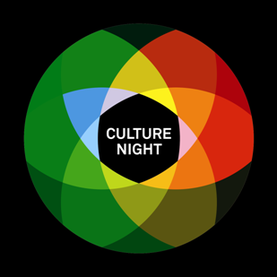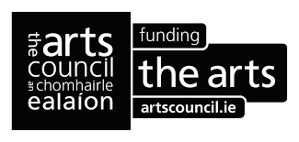

Open Call for Inclusion in Culture Night Sligo 2021 Programme
Culture Night is an annual all-island public event that celebrates culture, creativity and the arts. This year, it will take place on Fri 17 September 2021. On Culture Night, events of all shapes and sizes take place between 4pm and 10pm. Special and unique events are specifically programmed at participating locations and everything is available FREE of charge.
Culture Night Sligo has become a widely anticipated event as the public enjoy the many events across Sligo. If you are planning an event for Culture Night 2021 please note that the deadline for inclusion in the Culture Night Sligo 2021 programme is Friday, August 6th 2021.
Culture Night happens because many people share a vision and enthusiasm for enjoying, celebrating and promoting creativity and culture. While we approach this year’s Culture Night with optimism, we ask participants to keep public health safety guidelines to the forefront of their minds during the planning stages and to consider the possibility of necessary last-minute changes in light of the ever-changing situation with COVID-19. We hope Culture Night 2021 will offer the opportunity for our audiences to engage with a variety of cultural events and to benefit from the pleasure they bring to us.
If you would like your Culture Night Sligo event to be included in the programme please complete the application form below and e-mail it to culturenightsligo2021@gmail.com by the deadline of Friday, August 6th 2021.
Culture Night Sligo 2021 is co-ordinated by The Model Sligo on behalf of Culture Night Sligo partner venues Sligo Arts Service, The Model, The Hawk’s Well Theatre, Blue Raincoat Theatre Company, Sligo Youth Theatre, Yeats Society Sligo, and is brought to you by The Arts Council in partnership with Sligo County Council.
For further information contact our team at culturenightsligo2021@gmail.com or call The Model, Sligo on 071 9141405

**Please complete form below**

CONTACT PERSON DETAILS (Private)
FIRST NAME
LAST NAME
EMAIL
TEL

ORGANISATION DETAILS (Public)
ORGANISATION
NAME
PUBLIC PHONE NUMBER
ADDRESS
EIRCODE
WEBSITE
Broadcast Platform | *Website/Video Stream/Social Media/Ticketed Stream  (please specify)

EVENT DETAILS
Event description for Culture Night publicity material:
Online/Live
Organisation
Type of Event
Title
Time (eg. 4 pm to 6pm)
50-word max description

Broadcast platform/Venue/Location
Family friendly?
Wheelchair accessible?
2 x High Resolution images attached

